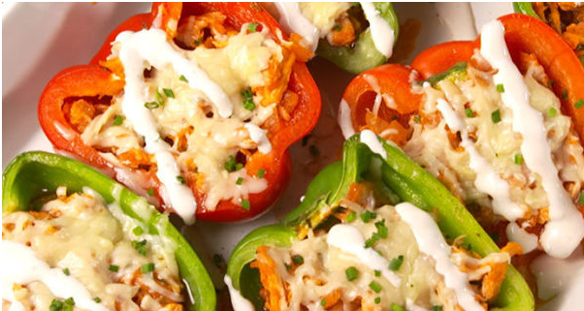

<http://www.delish.com/cooking/recipe-ideas/recipes/a51994/buffalo-chicken-stuffed-peppers-recipe/>

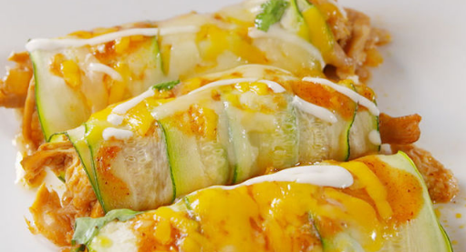

<http://www.delish.com/cooking/recipe-ideas/recipes/a51783/zucchini-enchiladas-recipe/>

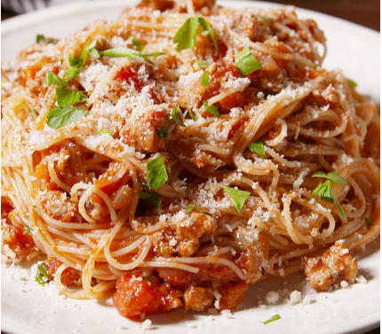

<http://www.delish.com/cooking/recipe-ideas/recipes/a50639/ground-turkey-bolognese-recipe/>

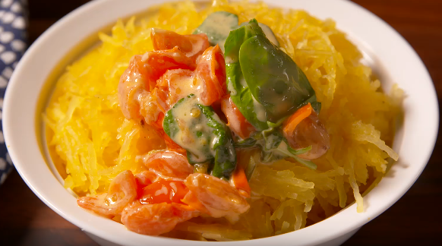

<http://www.delish.com/cooking/recipe-ideas/recipes/a50703/cheesy-tuscan-spaghetti-squash-recipe/>

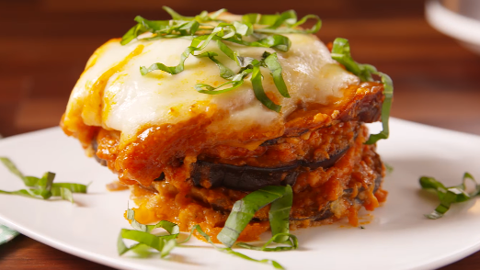

<http://www.delish.com/cooking/recipe-ideas/recipes/a50701/slow-cooker-eggplant-parm-recipe/>

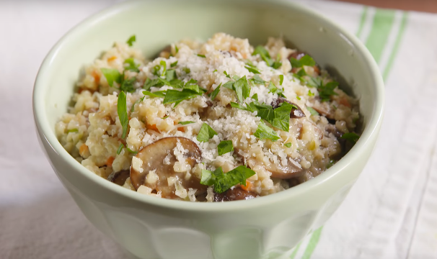

<http://www.delish.com/cooking/recipe-ideas/recipes/a50189/mushroom-risotto-with-riced-cauliflower-medley-recipe/>

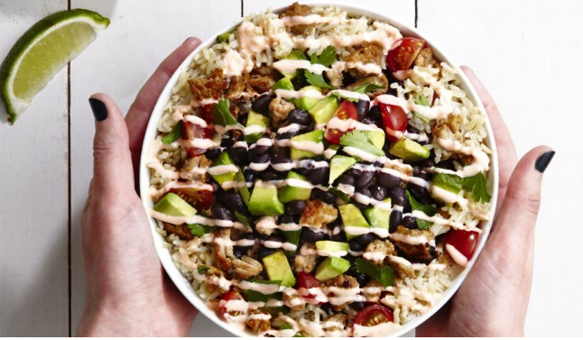

<http://www.delish.com/cooking/recipe-ideas/recipes/a46525/skinny-burrito-bowl-recipe/?visibilityoverride>

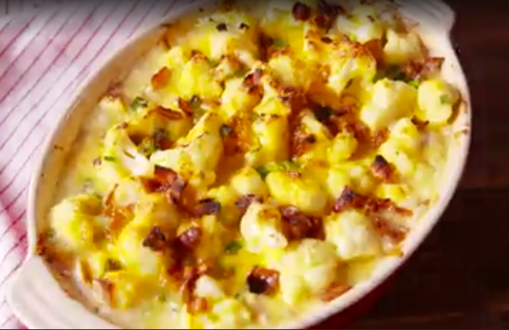

<http://www.delish.com/cooking/recipe-ideas/recipes/a49535/loaded-cauliflower-bake-recipe/>

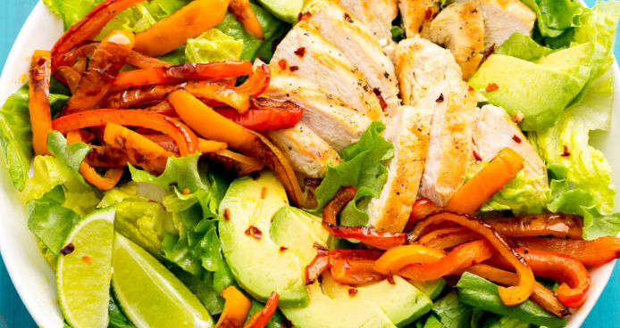

<http://www.delish.com/cooking/recipe-ideas/recipes/a47332/fajita-chicken-salad-recipe/>